Name: Archanaben Patel

Class:Cosc631

=====================================================================================

**Description**:

**Project Language**: java

**IDE** : eclipse java

**JOB**:

This project is about query optimization. This project will remove the redundancy conditions and print the final query tree.

This java project connected with the external database which have following tables.

**CUSTOMERS**

--------------------------------------------------------------------------------------------------------------------------

NAME Domain/Data type DESCRIPTION

----------------------------------------------------------------------------------------------------------------------------

CUSTNO CHAR (5) Customer Number

CUSTNAME VARCHAR(20) Customer Name

ADDRESS VARCHAR(20) Customer Street Address

CITY VARCHAR(12) City Name

STATE CHAR(2) State Name

ZIPCODE CHAR(5) Zipcode Number

PHONE CHAR(12) (ddd)-ddd-dddd

**STOCK**

--------------------------------------------------------------------------------------------------------------------------

NAME Domain/Data type DESCRIPTION

----------------------------------------------------------------------------------------------------------------------------

PRODNO CHAR(5) Product Number

DESCRIPTION VARCHAR(20) Product Description

COST NUMBER(5,2) Unit Cost of the product ($)

MARKUP NUMBER(5,2) % markup

QTYONHAND NUMBER(5)

VNUMB CHAR(5) Vendors number

**ORDERS**

------------------------------------------------------------------------------------------------

NAME Domain/Data type DESCRIPTION

-----------------------------------------------------------------------------------------------

CUSTNO CHAR(5) Customer Number

PRODNO CHAR(5) Product Number

QTYORD NUMBER(5) Quantity Ordered

ORDDATE DATE Date of Order

**VENDOR**

---------------------------------------------------------------------------

Name Domain Type Description

------------------------------- -------- -----------------------------------

VNUMB CHAR(5) Vendor Number

VNAME VARCHAR(20) Vendors name

VADDRESS VARCHAR(30) address

VCITY VARCHAR(12) city

VSTATE CHAR(2) state

VZIP CHAR(5) zip

VPHONE CHAR(12) (aaa)-(eee)-(eeee)

**SALES**

-------------------------------------------------------------------------------------------------------------

NAME Domain/Data type DESCRIPTION

-------------------------------------------------------------------------------------------------------------

SALENO CHAR(5) Sale number (PK)

PRODNO CHAR(5) Product Number (FK references

Inventory Table)

QTY_SOLD NUMBER(4) Quantity sold

Date_SOLD DATE Date sold

-------------------------------------------------------------------------------------------------------------

**Experiments**:

Try 1:

select description,qty_sold,cost,date_sold from stock,sales where cost>199 and cost>299 and sales.prodno=stock.prodno

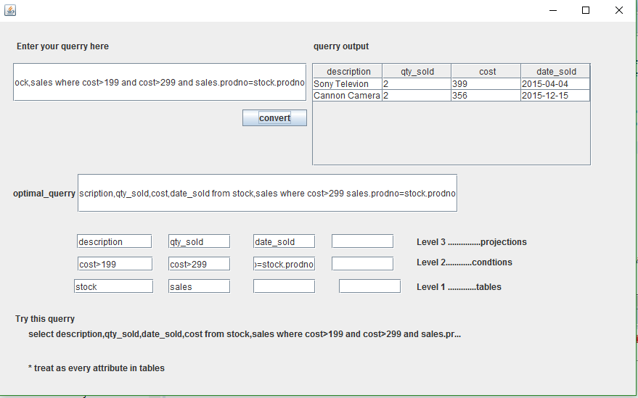

Try 2:

select description,qty_sold,cost,date_sold from stock,sales where cost>199 and cost<299 and sales.prodno=stock.prodno

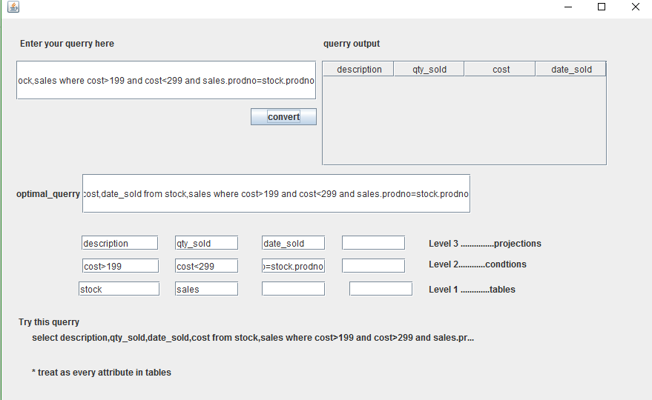

Try 3:

select description,qty_sold,cost,date_sold from stock,sales where cost<199 or cost<299 and sales.prodno=stock.prodno

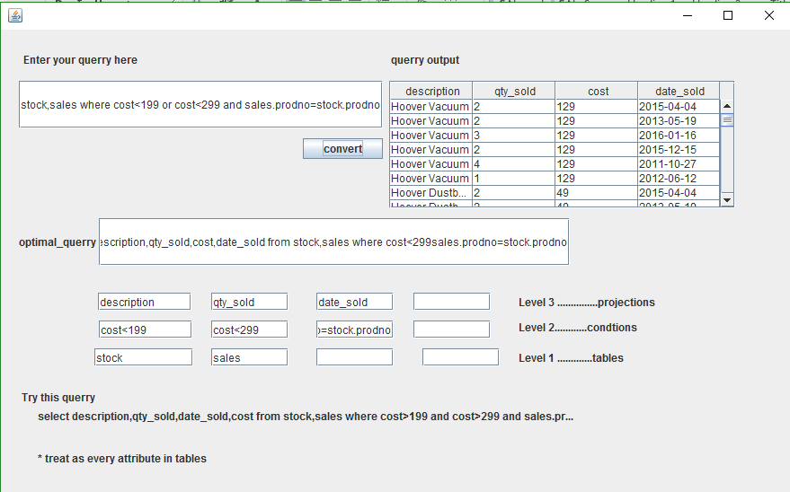

Try 4:

select description,qty_sold,cost,date_sold from stock,sales where cost<199 or cost<299 and sales.prodno=stock.prodno

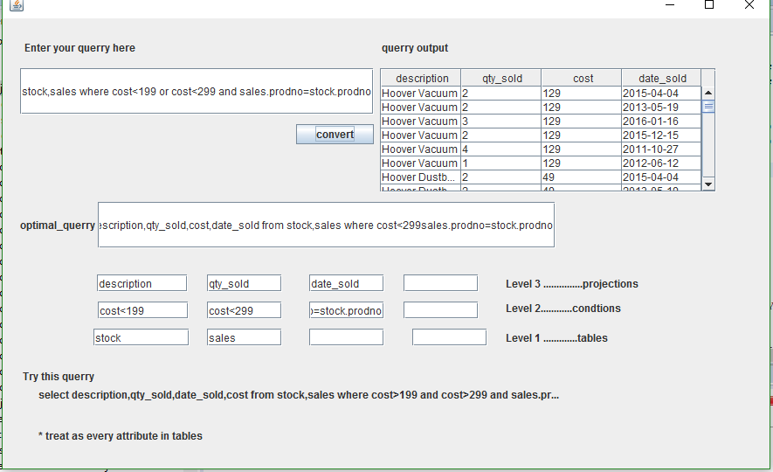

Try 5:

select cust_fname,cust_lname from customers where state='MD' or state='NY'

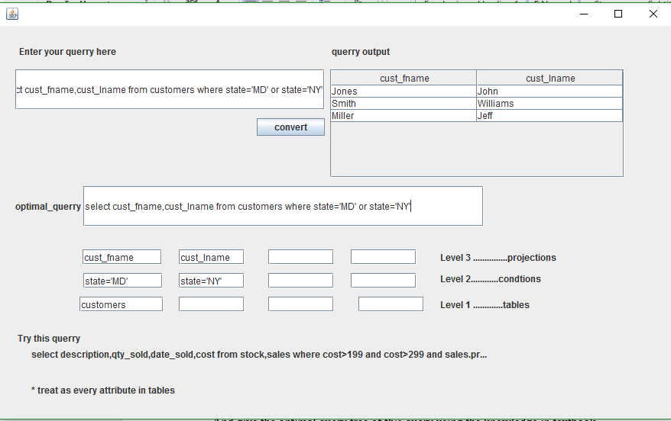

Try 6:

select description,qty_sold,cost,date_sold from stock,sales where sales.prodno=stock.prodno

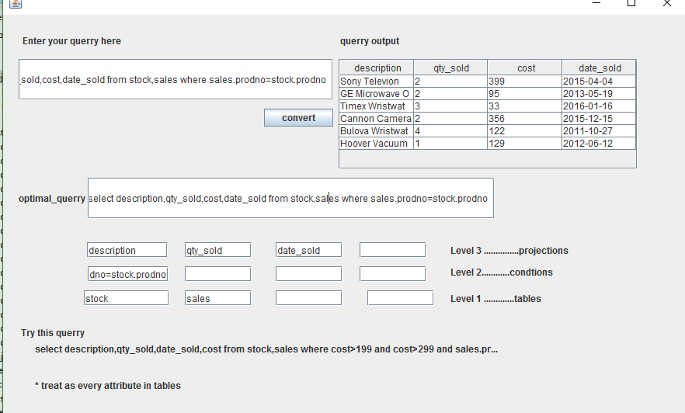

**Conclusions**: This project completely work with all kind of query including aliases,join,etc. I just mentioned some of them.